Input window asking for state

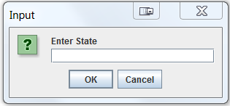

Input window asking for city

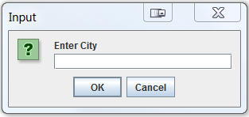

Results for chesterfield

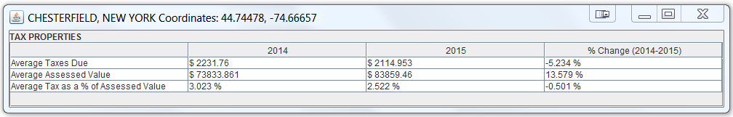

Results for crown point

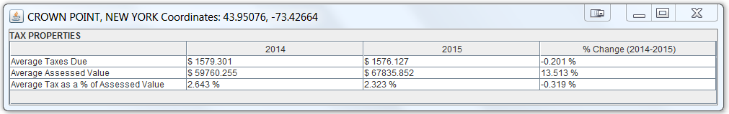

Results for Elizabethtown

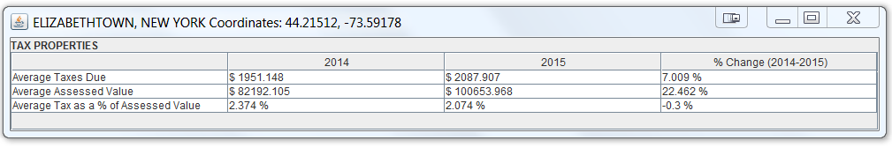

Results for essex

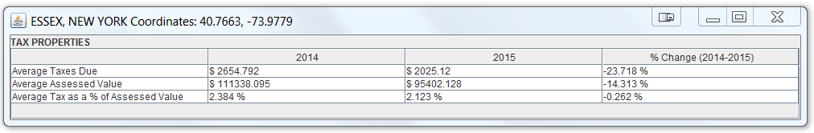

Results for jay

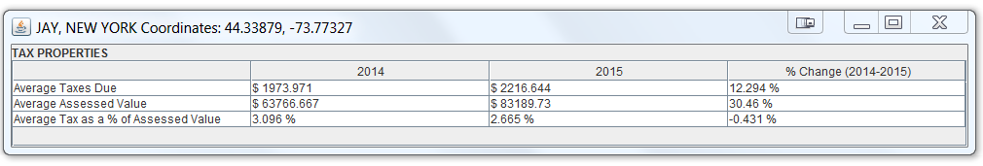

Results for keene

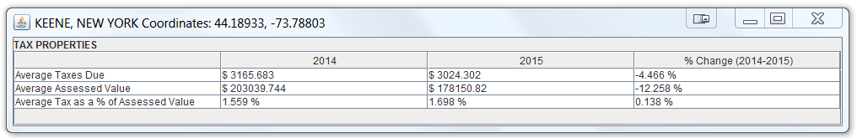

Results for Lewis

